**Address Book**

The software to be designed is a program that can be used to maintain an address book. An address book holds a collection of entries, each recording a person's first and last names, address, city, state, zip, and phone number.

Implement an Address Book using **Java**. There is some flexibility in how you choose to implement the Address Book; however you must include the methods below. You can add additional functionality to each class. Address Book includes the following classes:

**AddressBookController:** The basic responsibility of an AddressBookController object is to carry out the following functions:

1. Add, edit and delete a person
2. Sort entries by name and ZIP code
3. Create , update, save an existing address book
4. Print entries in the address book
5. Offer the user to save changes when necessary

**AddressBookGUI:** The basic responsibility of a GUI object is to allow interaction between the program and the human user.

|  |
| --- |
| 1. Keep track of the address book object it is displaying |
| 1. Display a list of the names of persons in the current address book |  |
| 1. Display the title of the current address book - if any |  |
| 1. Maintain the state of the "Save" menu option - usable only when the address book has been changed since the last time it was opened / saved. |  |
| [ Main class for the application ] |  |

**Database**: The basic responsibility of the database object is to manage interaction between the program and the database of the computer it is running on. These responsibilities include:

1. Read a stored address book from a database,
2. Save an address book to the database
3. Delete an address book from the database

**Class Person**: The basic responsibility of a person object is to maintain information about a single individual. Again you have flexibility here. These responsibilities include:

1. Create a new object, given an individual's name, address, city, state, ZIP, and phone
2. Get the individual's first name, last name, address, city, state, ZIP, phone number
3. Update the stored information (except the name) about an individual.

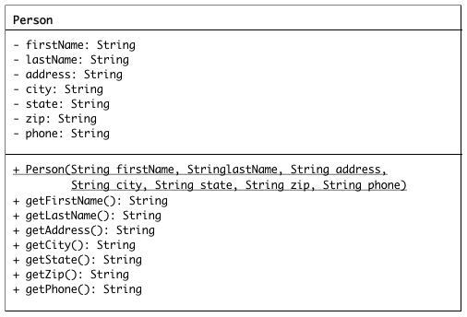

Please note that the development of this program was started, however it was poorly written and some aspects were never completed. It is your group’s responsibility to complete the development, unit and integration testing of the Address Book program.